SCREENSHOT DOCUMENTARY

Terminal Startup: A screenshot of your terminal showing the application successfully starting. The Spring Boot application successfully compiled and initialized on port 8080.
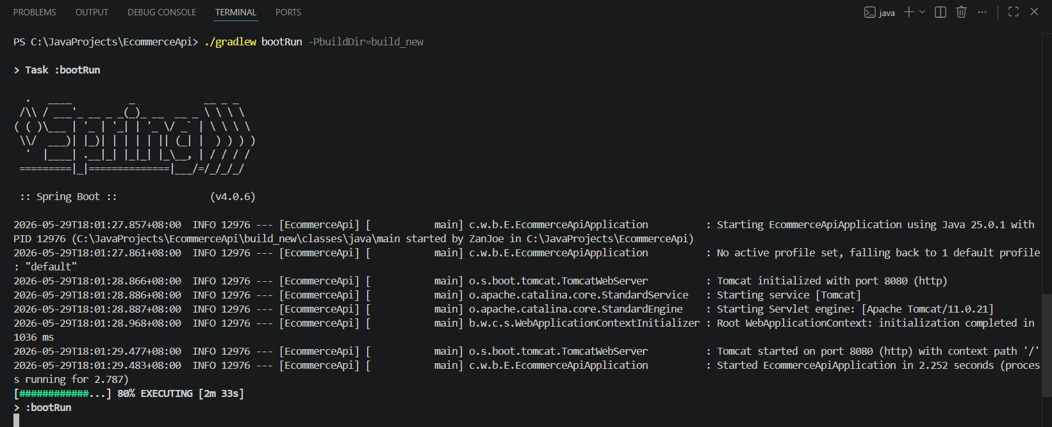

Figure 1: Application Initialization

Success Case: A screenshot of your API client—Thunder Client—showing a successful GET request to /api/v1/products. Successful retrieval of product data using the GET endpoint.
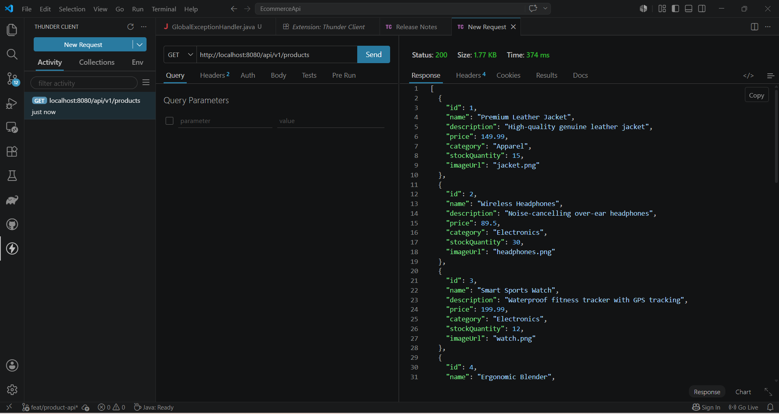
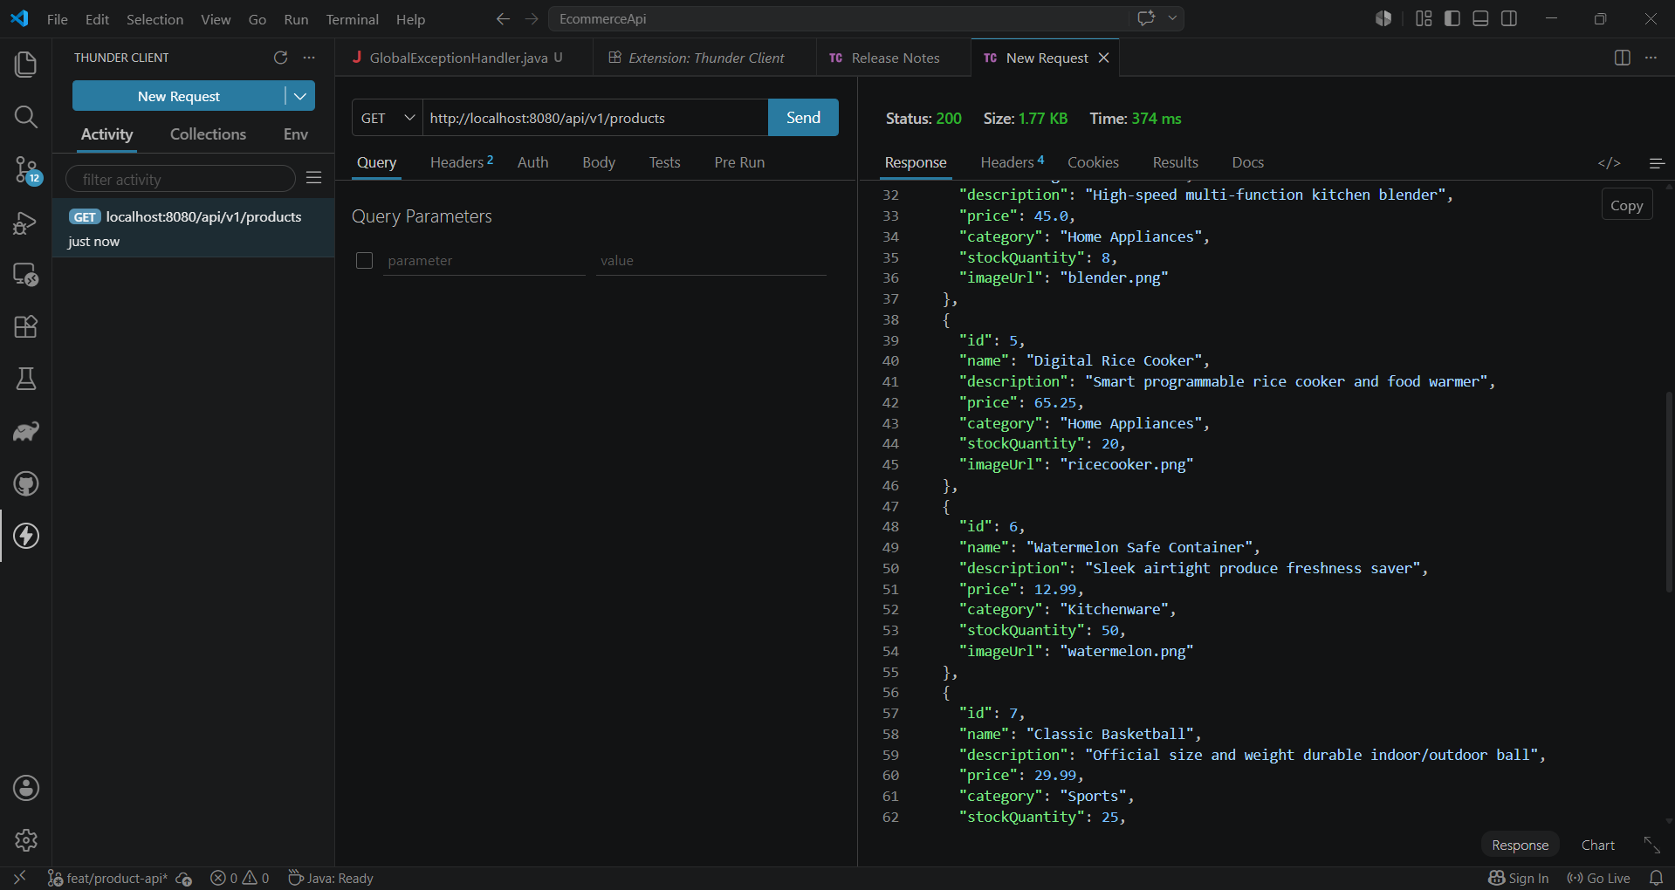
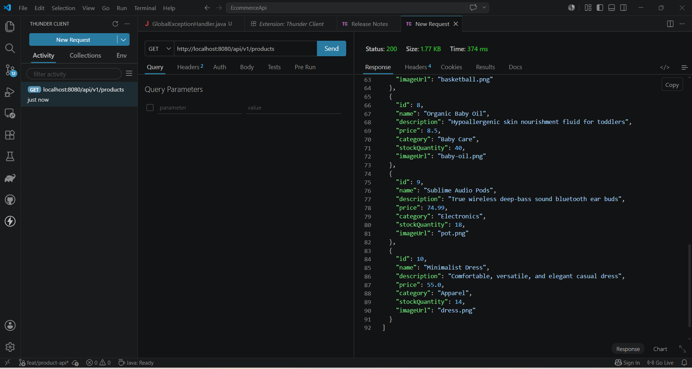
Figures 2: Success API Product Retrieval

Error Case (404 Not Found): A screenshot showing you requesting a product ID that does not exist /api/v1/products/999 and the response showing the 404 Not Found status along with your custom error message. Demonstration of the GlobalExceptionHandler catching an invalid product ID request.
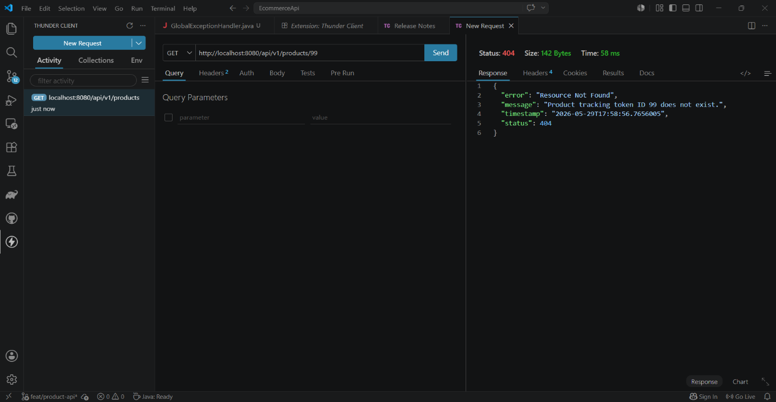

Figure 3: Global Exception Handling

